Course Report
1-week customized course on
“Remote Sensing & GIS Technologies for Water Resources Applications”
(21 - 25 Jun 2021)

National Hydrology Project (NHP) is being taken up by the Ministry of Jal Shakti, Govt. of India, and the mission objective is to aid in effective water resources planning, development and management. This Project is intended for setting up of a system for timely and reliable water resources measurement, storage, monitoring and management. It will also facilitate to provide tools/systems for informed decision making through Decision Support Systems (DSS) for water resources assessment, flood management, reservoir operations, drought management, etc. NHP also takes care of capacity building of the relevant State and Central government organizations in water resources management through the use of Information Systems and adoption of State-of-the-art technologies like Remote Sensing & GIS.
National Remote Sensing Centre (NRSC) has taken up the task to support NHP based on the request from Ministry of Jal Shakti through organizing capacity building training programs comprising of Remote Sensing & GIS technologies and customized applications on water resources. These programmes are aimed at capacity building of all the stake holders in understanding and effective utilization of space technology in the field of water resources. To this effect, two customized training programs per year of one week duration on the fundamentals aspects of RS & GIS and two customized programs per year of two weeks duration on the applications of RS & GIS in water resources are planned.
In this regard, a one-week customised training programme was conducted at National Remote Sensing Centre (NRSC) by Water Resources Group in association with Training & Education Group for Water Resources Engineers of Central / State government departments under National Hydrology Project during 21-25, Jun 2021. Due to Covid-19 pandemic situation across the country the training programme was conducted in Webinar mode. The details of which are described below.
The training programme was inaugurated on 21-Jun-2021 and chaired by Dr. P.V.N. Rao, Deputy Director, Remote Sensing Applications Area, NRSC and co-chaired by Dr. M.V. Ravi Kumar, Deputy Director, Management Systems Area, NRSC. Dr.V.V. Rao, Group Director (WR) and Project Director (NHP) welcomed all the participants and gave overview of the training programme. Dr. P.V.N. Rao, Deputy Director, Remote Sensing Applications Area, NRSC addressed the trainee officers and briefed about NHP activities including capacity building. A total of 29 officials were registered for this course from water resources departments of both Central and State Governments (refer Annexure-1).

The course is designed in such a way that it covers the overall concepts of Remote Sensing & GIS starting from the fundaments to hands-exercises (Annexure-2). The first day, the participants are briefed about remote sensing and image interpretation techniques with hands on exercises after post lunch session.
Second day, they are introduced to Geographic Information System (GIS) and spatial data analysis techniques including hand-on exercises covering basic GIS tools utilisation. Third day topics covered include, Digital Elevation Model (DEM) generation concepts and its applications in water resources, open source-GIS and hand-on exercises on open source-GIS. The fourth day topics covered include satellite remote sensing applications in water resources, open data sources and open source software’s for water resources, hands on exercise for delineation of catchment and drainage from DEM. The final day topics covered are satellite data products & dissemination, water resources information portals, space based products for water resources, and introduction to Bhuvan and demo.
Online feedback was obtained from all the participants on the overall training programme and on each topic-wise. The trainees expressed happiness for including more hands on practical exercises in GIS. The ratings are good and the overall course feedback is 4.50 out of 5.

The concluding session was held on 25-Jun-2021 and was chaired by Dr.V.V. Rao, Group Director (WR) and Project Director (NHP). The Training Programme was concluded with feedback from the Trainee Officers and remarks by the chair.

Photograph taken during Inaugural Session of Webinar
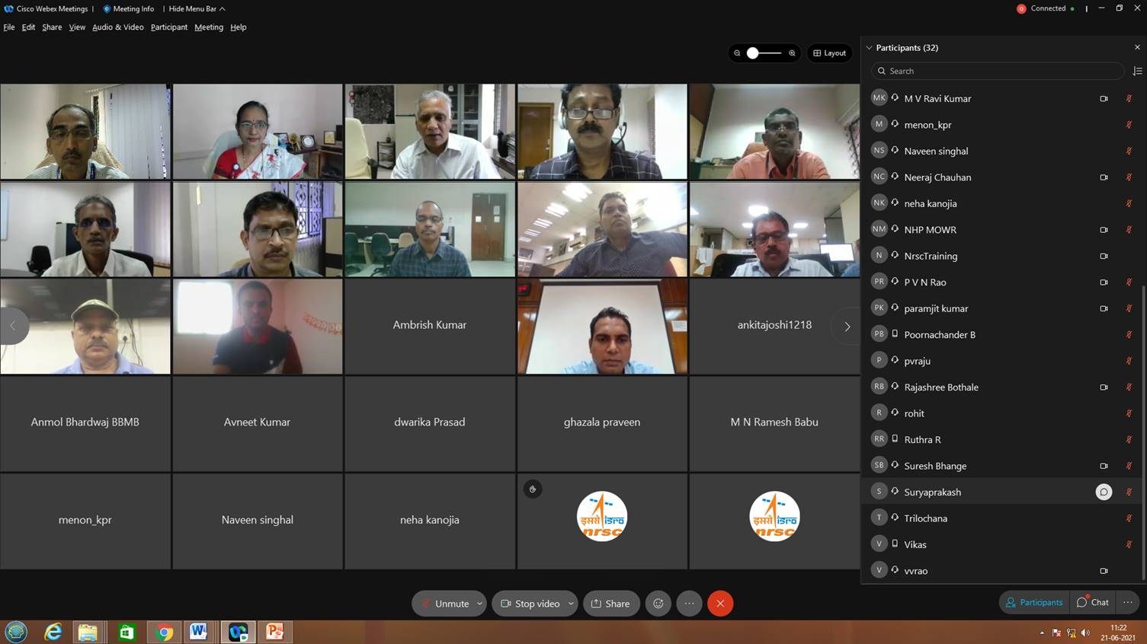

Annexure 1
List of Officers Registered for the Training Programme
Sr. No. | Name | Designation | Address
1 | Dwarika Prasad | Research Assistant | Water Resources Department, Government of Assam  Nit silchar dist. Cachar Assam  pin code 788010
2 | Anmol Bhardwaj | Junior Engineer | Bhakra Beas Management Board, BBMB, Chandigarh
3 | Paramjit kumar | Assistant Engineer | Bhakra Beas Management Board, BBMB, Chandigarh
4 | Anjali Kushwaha | Scientist B | Central Ground Water Board,149a, Kanwali Road, Near Urja Bhawan, Dehradun, Uttarakhand
5 | Mohammad Danis Khan | Hydrogeologist | Central Ground Water Board,L.K. Logistics park Dumertarai Raipur
6 | Md Shadman | Hydrogeologist | Central Ground Water Board,30 C First floor 1 B Park Road Ashok Nagar- Ranchi 834002 (Jharkhand)
7 | Vikas Kumar Dubey | Assistant Engineer | Water Resources Department, Government of Chattishgarh, Executive Engineer MRP Disnet Dn 3 Tilda District Raipur CG
8 | Ananya Gupta | Assistant Engineer | Water Resources Department, Government of Chattishgarh ,  DD hydrometeorology, data center, Raipur, C.G.
9 | Sreerama Naik SR | Senior Research Officer | Irrigation and Flood Control Department, Government of NCT Delhi
10 | Suryaprakash Bhanubhai Suryavansi | Senior Research Officer | Water Resources Department , Government of Gujarat, College of Agricultural Engineering and Technology,Anand Agricultural University,Dahod Road, Dholakuva, Godhra-389 001
11 | Sh. AKASH SHARMA | IT Specialist | Irrigation & Public Health Department, Government of Himachal Pradesh  State Data Centre Dhangsidhar, Mandi
12 | Ambrish Kumar | Junior Engineer | O/O The Executive Engineer, Design Division No. -2, Deoghar, At- Campus Of O/O Chief Engineer,Water Resources Department, Deoghar, Circular Road,Deoghar, Jharkhand
13 | Prasad Prabhakar Kulkarni | Junior Engineer | Water Resources Department, Government of Maharashtra Hydrology Project Subdivision, Irrigation Colony, Newasa Phata, At Post- Mukindpur, Tehsil-Newasa,Dist-Ahmednagar.
14 | Suresh Bhima Bhange | Junior Engineer | Water Resources Department, Government of Maharashtra Hydrology Project Sub Division Newasa Ta Newasa Dist Ahmednagar
15 | Jitendra Hatwar | Consultant | Water Resources Department, Government of Maharashtra  803, A-3, 10elite, Katepuram Chowk, Pimple Gurav, Pune 411061
16 | Blinington Shylla | Assistant Engineer | Water Resources Department , Government of Meghalaya  West Jaintia Hills District,Jowai
17 | Ravi kumar | Research Officer | Isotope Lab HI Division NIH Roorkee Roorkee, India
18 | Gagandeep Singh | Sub Divisional Officer | Department of Irrigation , Government of Punjab  Water Resources Bhawan Sector 68, Mohali
19 | Trilochana Basnett | GIS Specialist | Water Resources & River Development Department, Government of Sikkim  SPMU, National Hydrology Project, Sokeythang, Gangtok, Sikkim
20 | Ruthra R | GIS Assistant | Water Resources Department, Government of TamilNadu
21 | B. Poornachander | GIS Assistant | Water Resources Department, Government of TamilNadu
22 | Venkatesh | Geologist | Water Resources Department, Government of TamilNadu O/o EE,AED, Kumaraswamypatty,salem,TN.
23 | G.Kannadasan | Assistant Engineer | Water Resources Department, Government of TamilNadu  Project Management Unit-ADB Trichy-20
24 | Naveen | Superintending Engineer | Irrigation Department, Government of Uttarakhand  Design Circle, IDO, Roorkee
25 | Neha | Assistant Engineer | Irrigation Department, Government of Uttarakhand  irrigation research institute,roorkee
26 | Ankita Joshi | Research Assistant | Irrigation Department, Government of Uttarakhand  State Project Monitoring Unit, NHP, IRI, Roorkee
27 | Ghizala Praveen | Research Assistant | Irrigation Department, Government of Uttarakhand  Remote Sensing Lab, Irrigation Research Institute, Irrigation Department Uttarakhand
28 | Avneet Kumar Bharti | Research Assistant | Irrigation Department, Government of Uttarakhand  SPMU, NHP, IRI, ROORKEE
29 | Vinay Sanjay Sule | Executive Engineer | Irrigation and Waterways Department, Government of West Bengal 20, GARDEN REACH ROAD KOLKATA

Annexure 2

TRAINING PROGRAMME SCHEDULE
Date&Time | Title of the Lecture | Faculty
Day-1 : 21 Jun2021(Monday)
1000 - 1030 hrs | Webinar Registration | TEG
10:30-11:00 hrs | Inaugural Session | WRG & TEOG
11:00-12:00 hrs | Introduction to Remote Sensing | Mr. P. Chandrasekhar, TEG
12:00-13:00 hrs | Image Interpretation Techniques | Mr. T. S. Viswanadham, TEG
13:00-14:00 Lunch Break
14:00-15:00 hrs | Open Sources GIS (QGIS) (Theory & Demo) | Mr. P. Hariesh , TEG
1500-1630 hrs | Hands on Exercise in Image Interpretation  (Rivers, Water bodies, vegetation, etc) | Mr. P. Hariesh, TEG
Day-2 : 22 Jun2021(Tuesday)
10:30-11:45 hrs | Introduction to GIS | Mr. PVSSN Gopalakrishna, TEG
11:45-13:00 hrs | Spatial Data Analysis Techniques | Mr. T. S. Viswanadham, TEG
13:00-14:00 Lunch Break
14:00-16:30 hrs | Hands on Exercise in GIS (shape file creation, subset, point to spatial conversion, dissolve, etc.) | Mr. P. Hariesh, TEG
Day-3 : 23 Jun2021(Wednesday)
10:30-11:45 hrs | DEM Generation Concepts and its Applications in Water Resources | Mrs. J. Nalini, AS&DMG
11:45-13:00 hrs | Hands onExercise in OpenSource GIS(querying, buffering, GIS operations, etc.) | Mr. T. S. Viswanadham, TEG
13:00-14:00 Lunch Break
14:00-16:30 hrs | Hands-on Exercise in Open Source GIS(querying, buffering, GIS operations, etc.) | Mr. T. S. Viswanadham, TEG
Day-4 : 24 Jun2021(Thursday)
10:30-11:45 hrs | Satellite Remote Sensing Applications in Water Resources | Mr. B. SimhadriRao, WRG
11:45-13:00 hrs | Open Source Data & Software for Water Resources | Mr. Saksham Joshi, WRG
13:00-14:00 Lunch Break
14:00-16:30 hrs | Hands on Exercise in Catchment and drainage delineation using DEM | Mr. V Yogesh Palenivel, WRG
Day-5 : 25 Jun2021(Friday)
10:30-11:15 hrs | Satellite Data Products &Dissemination | G. Someshwara Rao, NDC
11:15-12:15 hrs | Water Resources Information Portals | Mr. K. Abdul Hakeem, WRG
12:15-13:00 hrs | Space based products for Water Resources Management (Bhoonidhi/MOSDAC/Vedas) | Mrs. Nidhi Mishra, WRG
13:00-14:00 Lunch Break
14:00-16:00 hrs | Introduction to Bhuvan and Demo (WBIS, VIC, LU/LC,AIBP, T-WRIS, etc) | Mr Kalyan / Mr Sai Rama Krishna BG&WSG
16:00-16:30 hrs | Valedictory

AS & DMG: Aerial Services & Digital Mapping Group | NDC : NRSC Data Centre
BG&WSG: Bhuvan Geo-portal & Web Services Group | T&EG: Training & Education Group
WRG: Water Resources Group

***

